Bansilal Ramnath Agarwal Charitable Trust’s
VISHWAKARMA INSTITUTE OF TECHNOLOGY – PUNE

Logic Design and Microprocessor

Division | A
Batch | 1
GR-no | 1251070524
Roll no | 1070120
Name | Samiksha Sanjay Adake

Assignment 1:

TITLE:-

Description:-

- Circuit Diagram

- Screenshots/Output:

NOT Gate

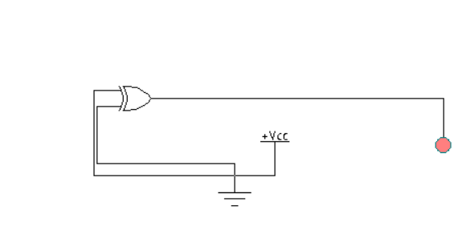
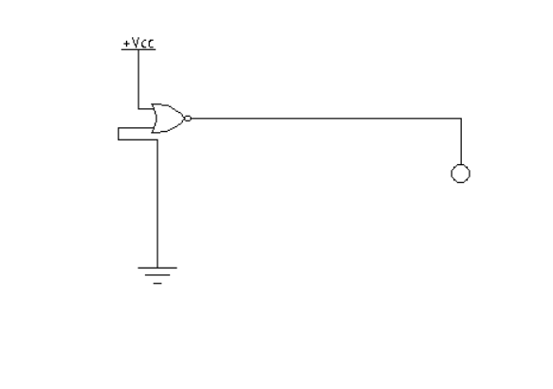

AND Gate

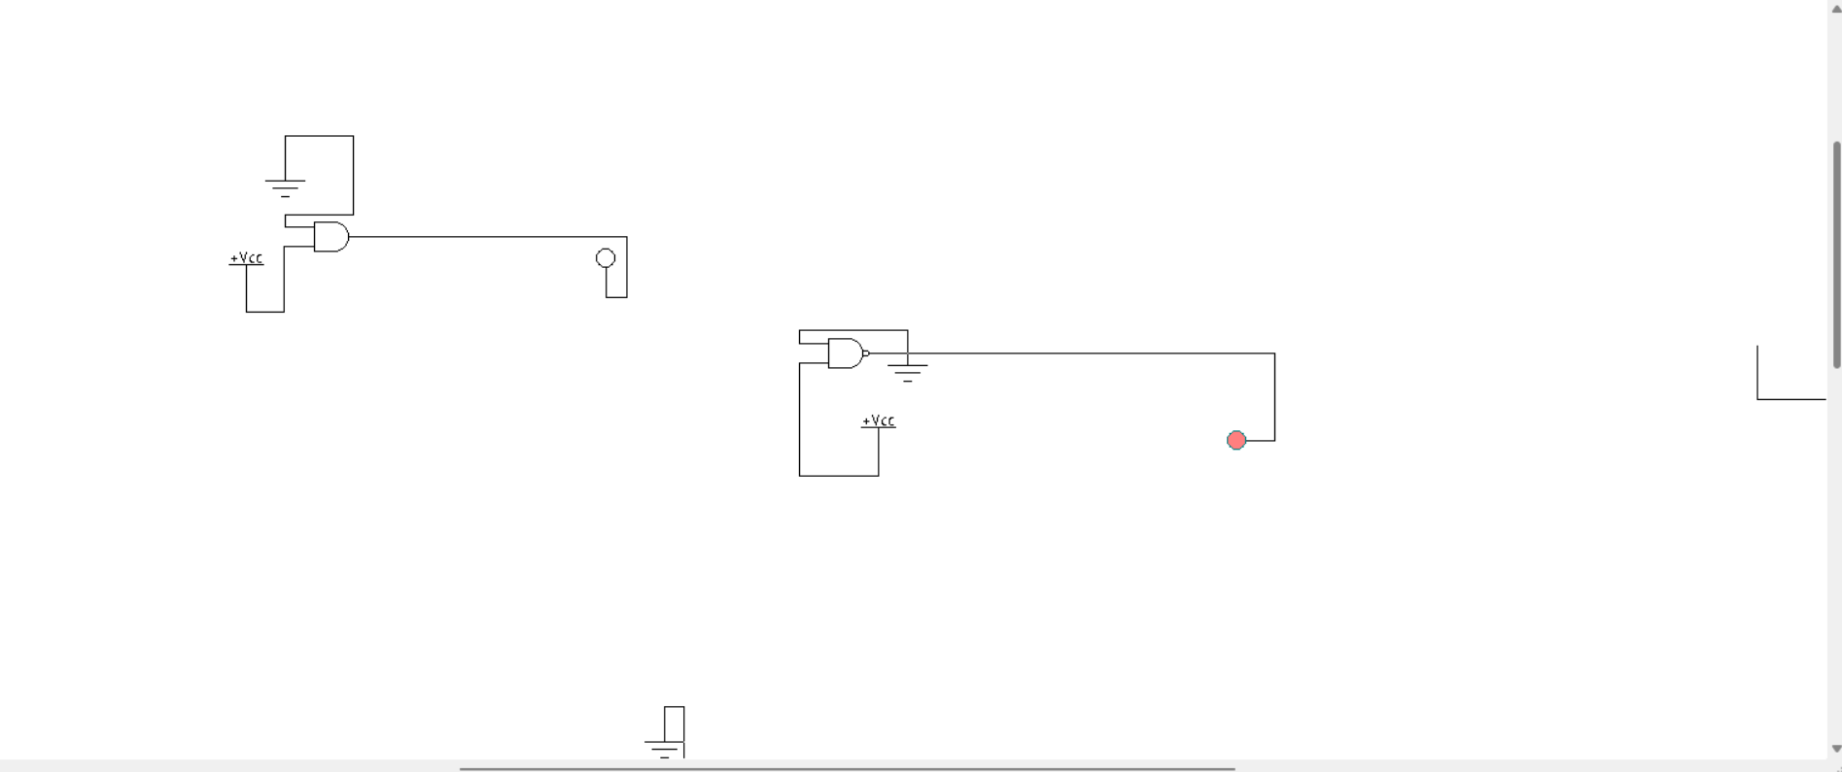

NAND Gate



XNOR Gate

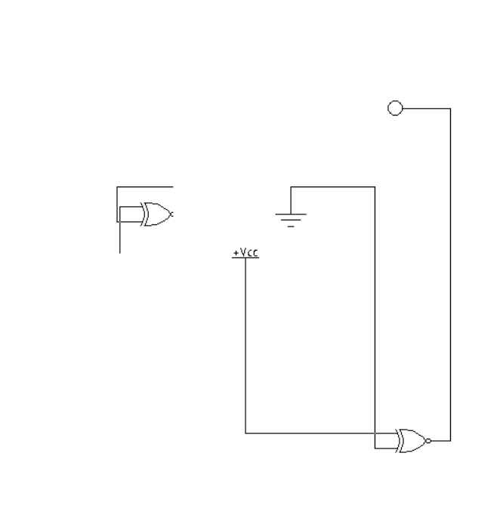

XOR Gate

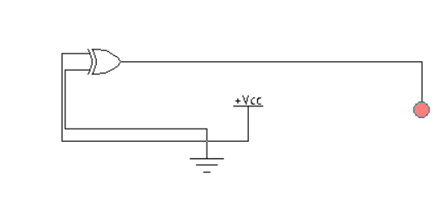

OR Gate

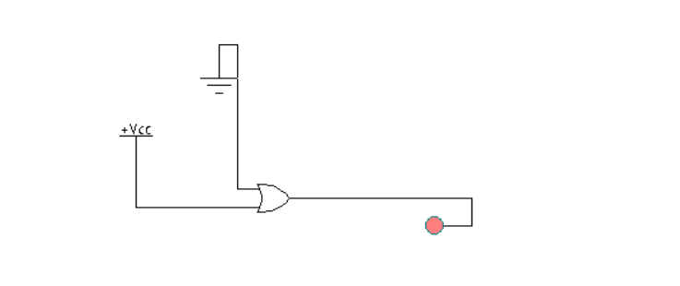


NOR Gate

